Gwelo Investments and Gwalwa Daraniki Association Inc Kulaluk lease Arafura Harbour Michael Chin
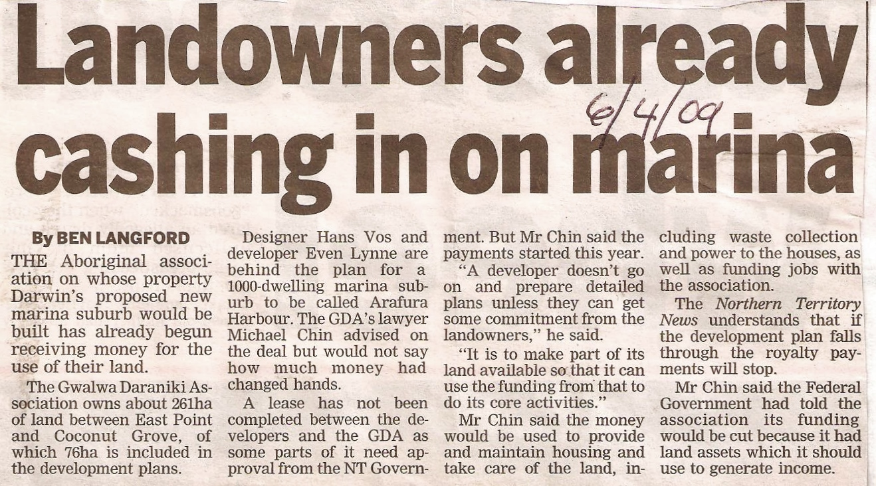
“Landowners already cashing in on marina” (NT News, April 4, 2009) . “The Aboriginal association on whose property Darwin's proposed new marina suburb would be built had already begun receiving money for the use of their land ... The GDA's lawyer Michael Chin advised on the deal but would not say how much money had changed hands … Mr Chin said that the payments started this year [2009].
'A developer doesn't go on and prepare detailed plans unless they can get some commitment from the landowners,' he said. 'It is to make part of its land available so that [the GDA] can use the funding from that to do its core activities.'”
(Note: Obviously “core activities” does not include land care or smoke alarms in homes).

